
BIKE RENTAL
sAMEER pANDEY
APRIL 05, 2019

Contents
Chapter 1: Introduction 4
1.1 Problem Statement 4
1.2 Variables 4
1.3 Sample Data 5
1.4 Unique count 5
Chapter 2: Methodology 6
2.1 Pre – Processing 6
2.2 Variable Identification 6
2.3 Univariate Analysis 7
2.3.1 Categorical Variables 7
2.3.2 Continuous Variables 8
2.4 Bi-variate Analysis 10
2.4.1 Correlation Plot of Continuous Variables 10
2.4.2 Box Plot B/W Categorical Predictor and Target Variable 10
2.4.3 Scatter Plot B/W Continuous Predictor and Target Variable 13
2.5 Missing Value Analysis 15
2.6 Outlier Analysis 15
2.7 Feature Selection 16
2.8 Feature Scaling 17
Chapter 3: Modelling 18
3.1 Model Selection 18
3.2 Decision Tree 18
3.2.1 Decision Tree for ‘cnt’ 18
3.2.2 Decision Tree for ‘registered’ 18
3.2.3 Decision Tree for ‘casual’ 18
3.3 Random Forest 19
3.3.1 Random Forest for ‘cnt’ 19
3.3.2 Random Forest for ‘registered’ 19
3.3.3 Random Forest for ‘casual’ 19
3.4 Linear Regression 19
3.4.1 Linear Regression for ‘cnt’ 19
3.4.2 Linear Regression for ‘registered 19
3.4.3 Linear Regression for ‘casual’ 19
3.5 XG Boost 20
3.5.1 XG Boost for ‘cnt’ 20
3.5.2 XG Boost for ‘registered’ 20
3.5.3 XG Boost for ‘casual’ 20
Chapter 4: Conclusion 21
4.1 Model Evaluation 21
4.1.1 Root Mean Square Error (RMSE) 21
4.1.2 Mean Absolute Percentage Error (MAPE) 21
4.1.3 Mean Squared Error (MSE) 21
4.1.4 R-squared 21
4.2 Model Selection 22
4.2.1 Model selection for ‘cnt’ variable 22
4.2.2 Model selection for ‘registered’ variable 22
4.2.3 Model selection for ‘casual variable 22
4.3 Key Prediction 23
Chapter 5: R Code 24
References 25

“Many many thanks to EDWISOR for teaching me and making me able to do projects in data science”

Chapter 1: Introduction

1.1 Problem Statement

The objective of this Case is to Predication of bike rental count on daily based on the environmental and seasonal settings.

1.2 Variables

There are 731 Observations and 16 variables in our data in which 13 are independent variables and 3 (Casual, Registered and Count) are dependent variables. Since the type of target variable is continuous, this is a regression problem.

Variable Information:

- instant: Record index
- dteday: Date
- season: Season (1:springer, 2:summer, 3:fall, 4:winter)
- yr: Year (0: 2011, 1:2012)
- mnth: Month (1 to 12)
- holiday: weather day is holiday or not (extracted from Holiday Schedule)
- weekday: Day of the week
- workingday: If day is neither weekend nor holiday is 1, otherwise is 0.
- weathersit: (extracted from Freemeteo) 1: Clear, Few clouds, Partly cloudy, Partly cloudy
2: Mist + Cloudy, Mist + Broken clouds, Mist + Few clouds, Mist
3: Light Snow, Light Rain + Thunderstorm + Scattered clouds, Light Rain + Scattered clouds
4: Heavy Rain + Ice Pallets + Thunderstorm + Mist, Snow + Fog
- temp: Normalized temperature in Celsius. The values are derived via
(t-t_min)/(t_max-t_min), t_min=-8, t_max=+39 (only in hourly scale)
- atemp: Normalized feeling temperature in Celsius. The values are derived via
(t-t_min)/(t_maxt_min), t_min=-16, t_max=+50 (only in hourly scale)
- hum: Normalized humidity. The values are divided to 100 (max)
- windspeed: Normalized wind speed. The values are divided to 67 (max)
- casual: count of casual users
- registered: count of registered users
- cnt: count of total rental bikes including both casual and registered

1.3 Sample Data

instant | dteday | season | yr | mnth | holiday | weekday
1 | 01-01-2011 | 1 | 0 | 1 | 0 | 6
2 | 02-01-2011 | 1 | 0 | 1 | 0 | 0
3 | 03-01-2011 | 1 | 0 | 1 | 0 | 1
4 | 04-01-2011 | 1 | 0 | 1 | 0 | 2
5 | 05-01-2011 | 1 | 0 | 1 | 0 | 3
6 | 06-01-2011 | 1 | 0 | 1 | 0 | 4

Table 1.1: Bike Rental Sample Data (Columns: 1-7)

workingday | weathersit | temp | atemp | hum | windspeed
0 | 2 | 0.344167 | 0.363625 | 0.805833 | 0.160446
0 | 2 | 0.363478 | 0.353739 | 0.696087 | 0.248539
1 | 1 | 0.196364 | 0.189405 | 0.437273 | 0.248309
1 | 1 | 0.2 | 0.212122 | 0.590435 | 0.160296
1 | 1 | 0.226957 | 0.22927 | 0.436957 | 0.1869
1 | 1 | 0.204348 | 0.233209 | 0.518261 | 0.0895652

Table 1.2: Bike Rental Sample Data (Columns: 8-13)

casual | registered | cnt
331 | 654 | 985
131 | 670 | 801
120 | 1229 | 1349
108 | 1454 | 1562
82 | 1518 | 1600
88 | 1518 | 1606

Table 1.3: Bike Rental Sample Data (Columns: 14-16)

1.4 Unique count
Below figure shows the unique count of all the variables present in the data.

List of columns and their number of unique values -
instant 731
dteday 731
season 4
yr 2
mnth 12
holiday 2
weekday 7
workingday 2
weathersit 3
temp 499
atemp 690

Chapter 2: Methodology

2.1 Pre – Processing

A predictive model requires that we look at the data before we start to create a model. However, in data mining, looking at data refers to exploring the data, cleaning the data as well as visualizing the data through graphs and plots. This is known as Exploratory Data Analysis. In this project we look at the distribution of categorical variables and continuous variables. We also look at the missing values in the data and the outliers present in the data.

Remember the quality of our inputs decide the quality of your output. So, once we have got our business hypothesis ready, it makes sense to spend lot of time and efforts here. Data exploration, cleaning and preparation can take up to 70% of our total project time.

Below are the steps involved to understand, clean and prepare our data for building model:

- Variable Identification
- Univariate Analysis
- Bi-variate Analysis
- Missing values treatment
- Outlier treatment
- Feature Selection
- Feature scaling

2.2 Variable Identification
From EDA we have concluded that there are 7 continuous variables (Including Target) and 7 categorical variables and one continuous target variable.

Target Variable = Casual, registered and cnt

Continuous variables | Categorical variables
temp | season
atemp | yr
hum | mnth
windspeed | holiday
casual | weekday
registered | workingday
count | weathersit

Table 1.4: Employee Absenteeism Variable Category

2.3 Univariate Analysis
At this stage, we explore variables one by one. Method to perform uni-variate analysis will depend on whether the variable type is categorical or continuous. Let’s look at these methods and statistical measures for categorical and continuous variables individually:

2.3.1 Categorical Variables

#Season #Year

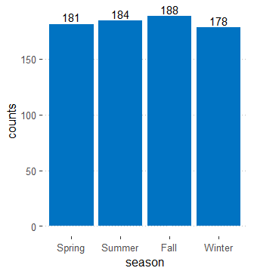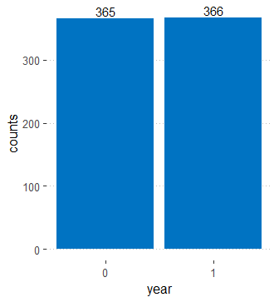

#month #Holiday

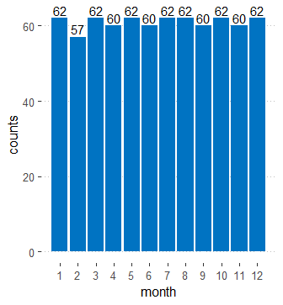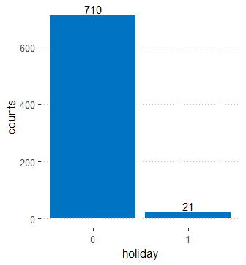

#Weekday #Working Day

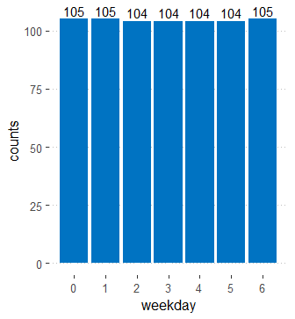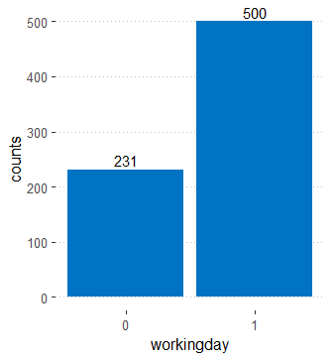

#Weather Situation

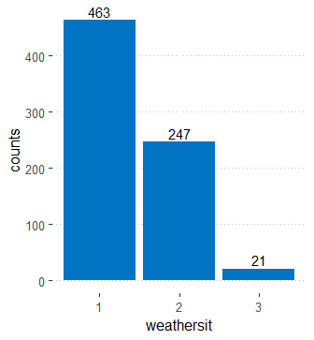

2.3.2 Continuous Variables
#Temp #atemp
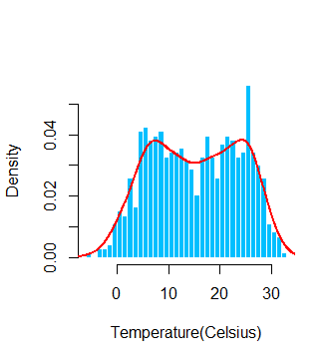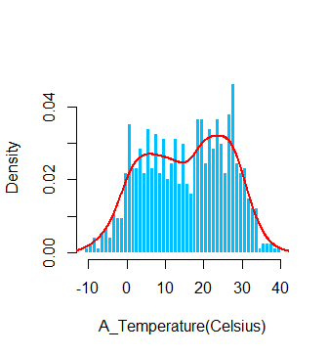

#hum #windspeed
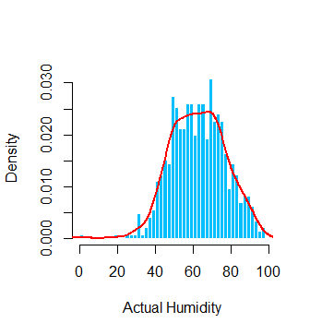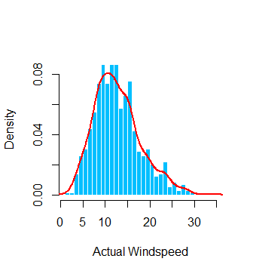

#casual #registered
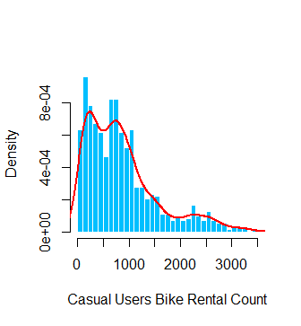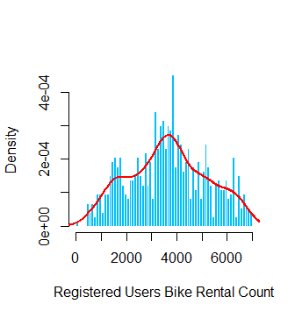
#cnt
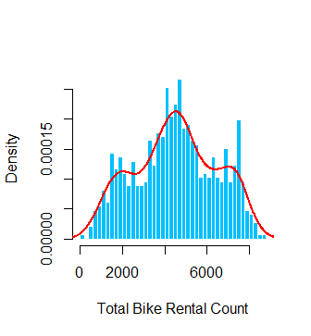

2.4 Bi-variate Analysis

2.4.1 Correlation Plot of Continuous Variables
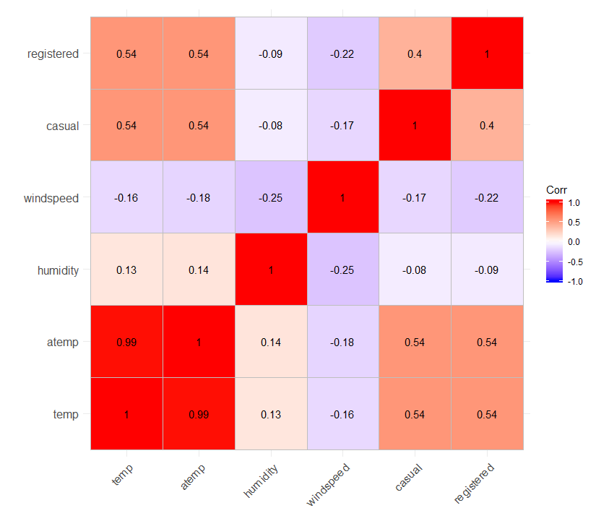

2.4.2 Box Plot B/W Categorical Predictor and Target Variable

#Season v/s Total Bike rental count

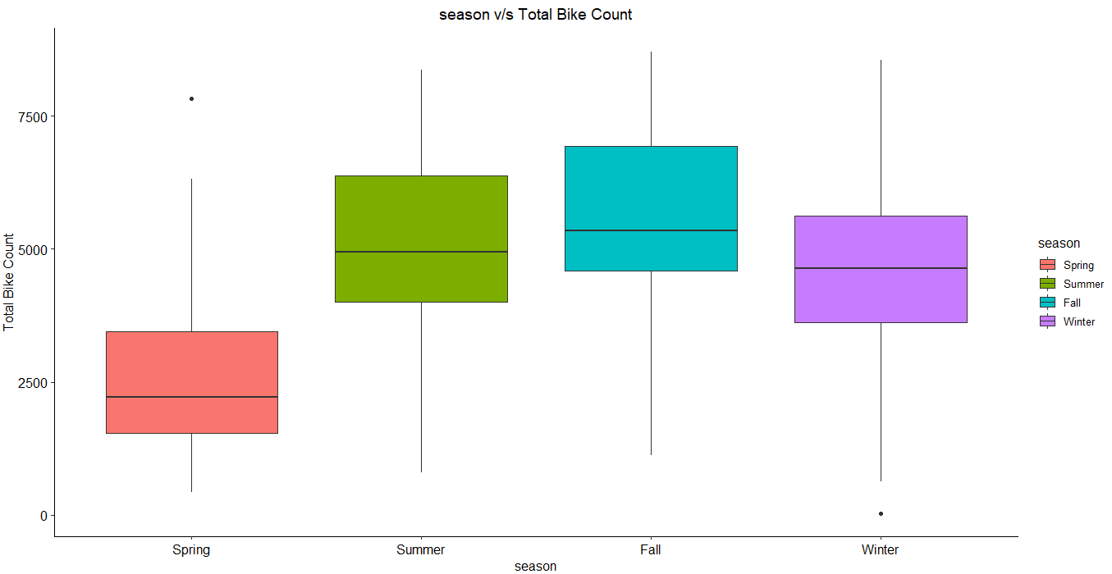

#Year v/s Total Bike rental count
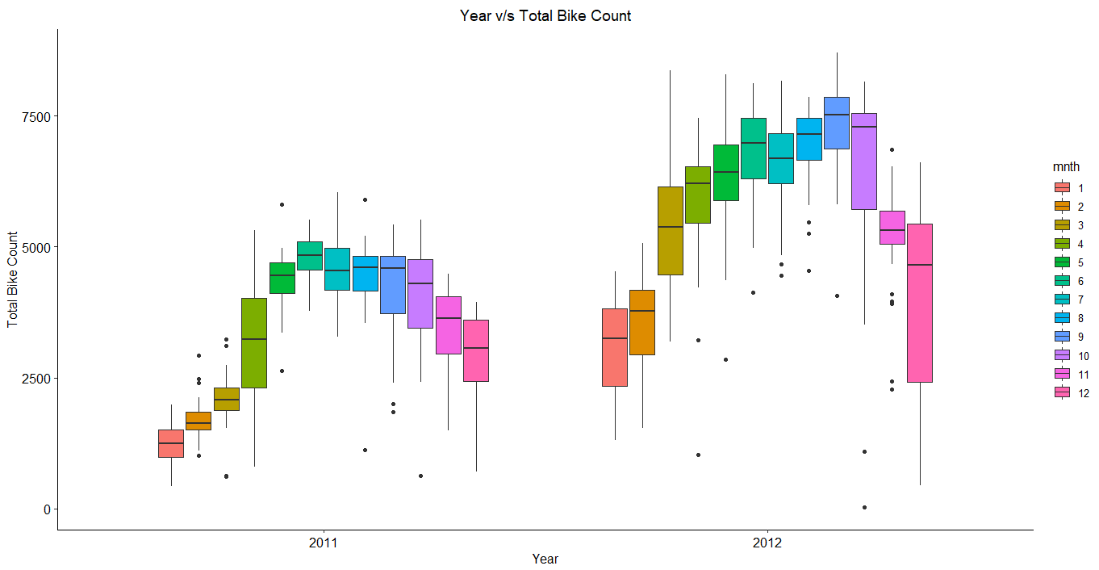
#Month v/s Total Bike rental count
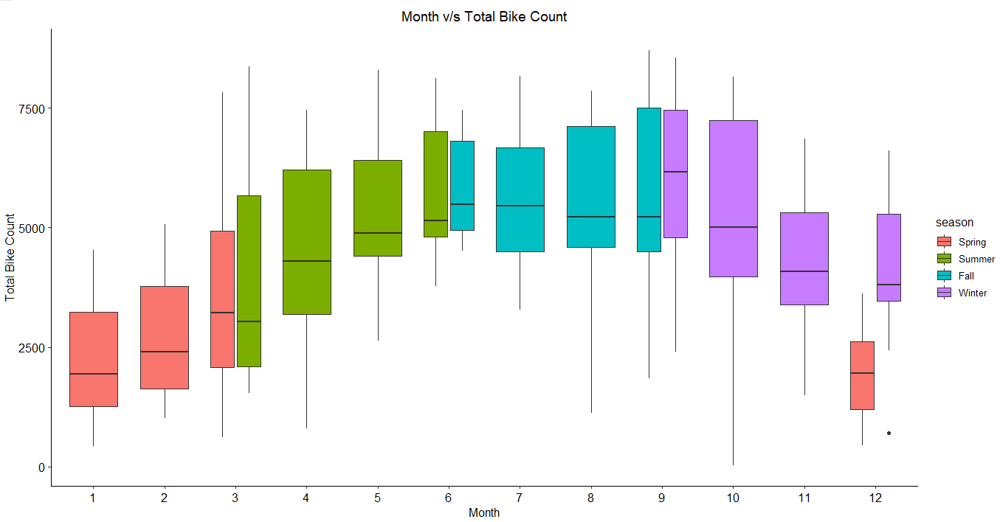

#Holiday v/s Total Bike rental count
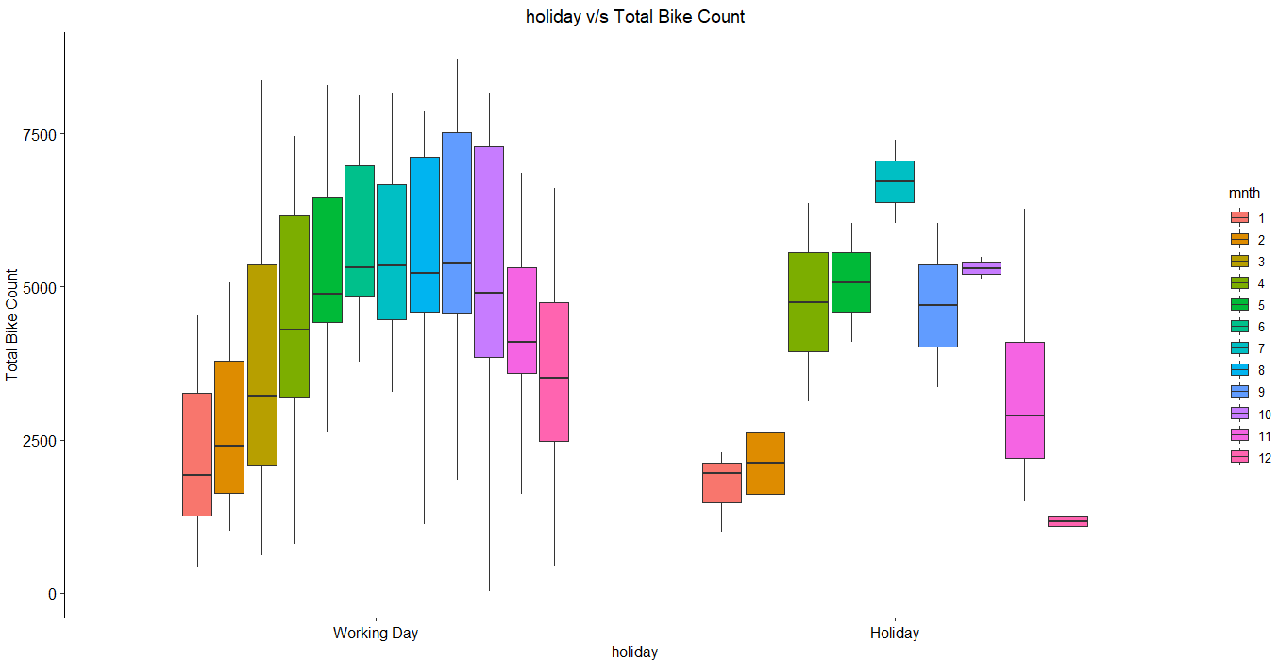

#Weekday v/s Total Bike rental count
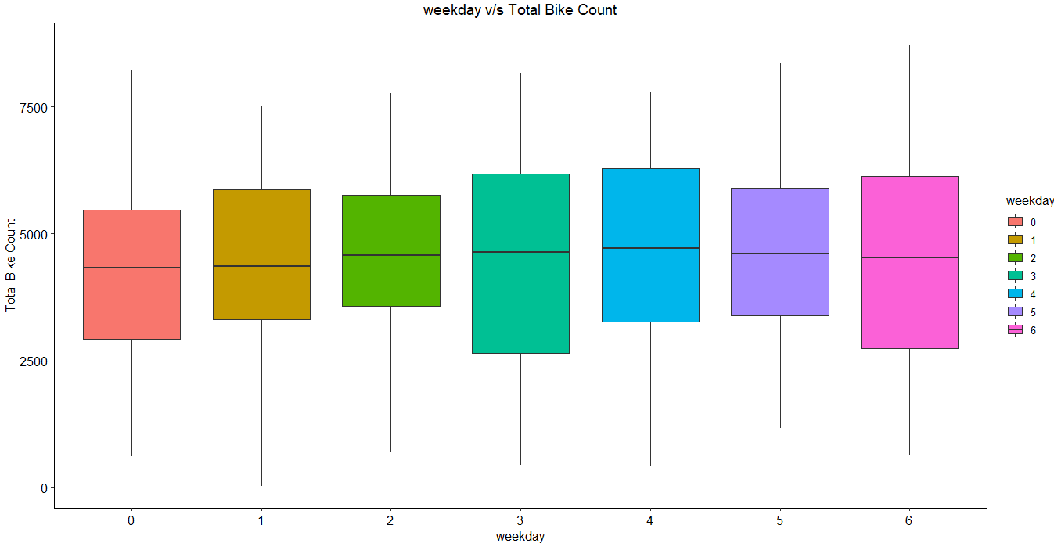
#Workingday v/s Total Bike rental count
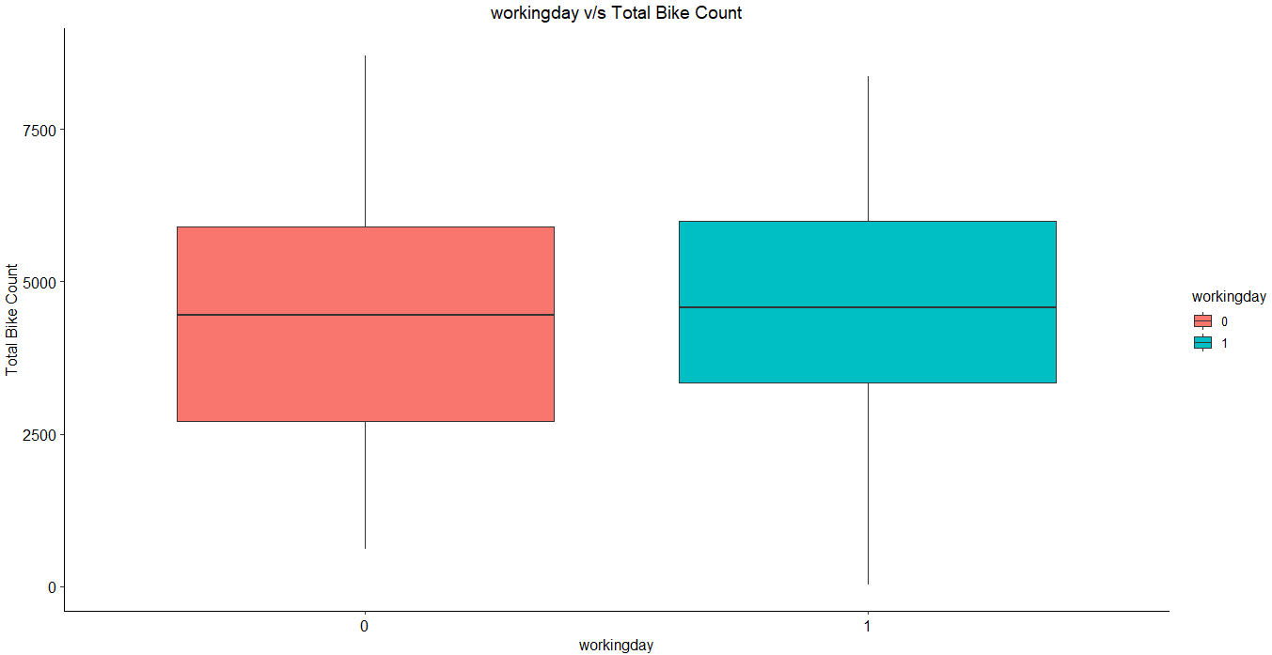
#Weathersit v/s Total Bike rental count
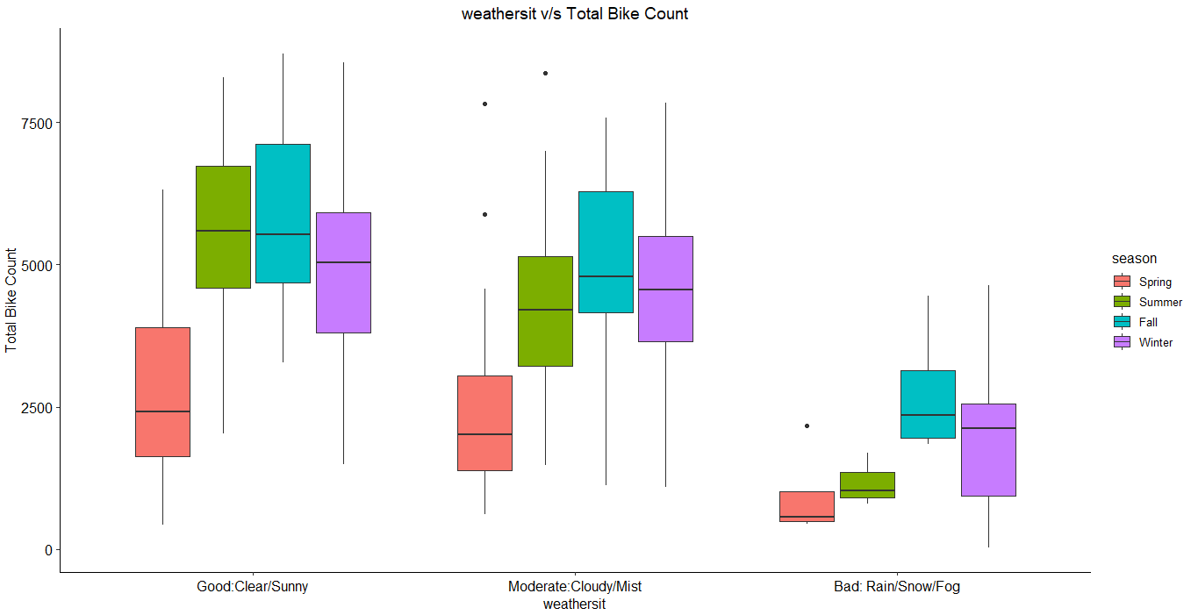

2.4.3 Scatter Plot B/W Continuous Predictor and Target Variable

#Temperature v/s Total Rental Count
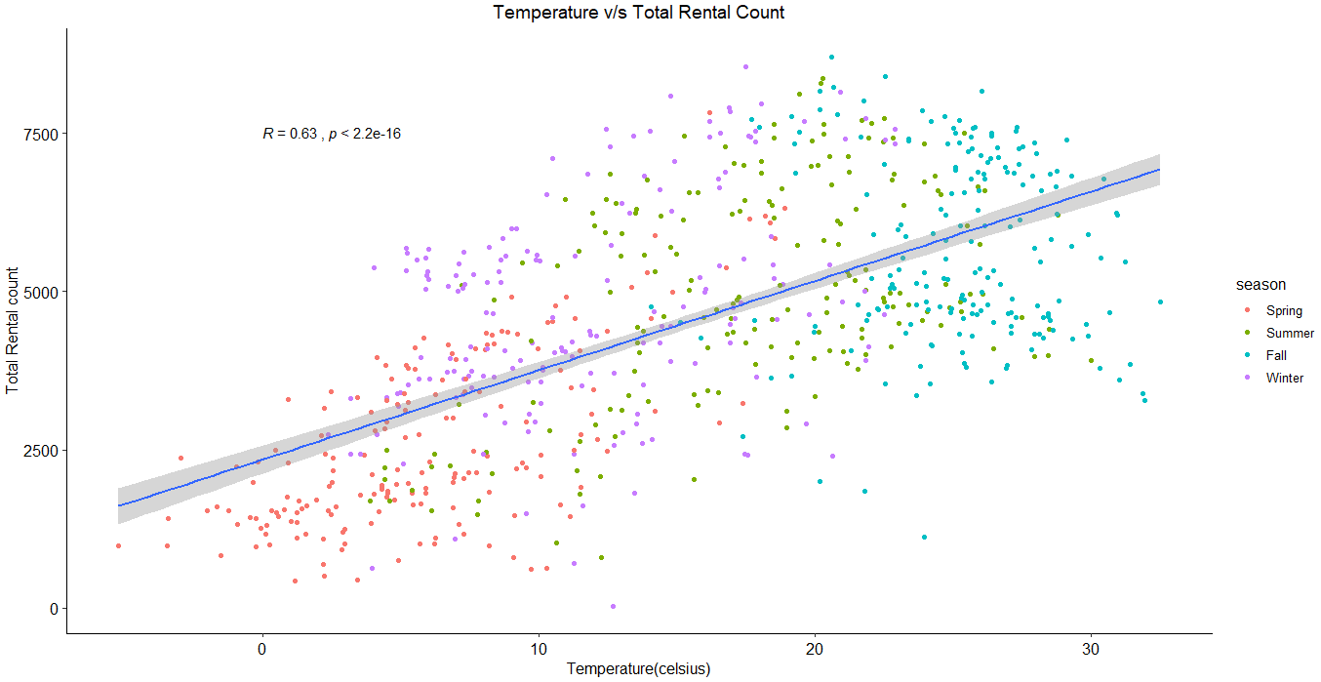

#"Feels Like" Temperature v/s Total Rental Count
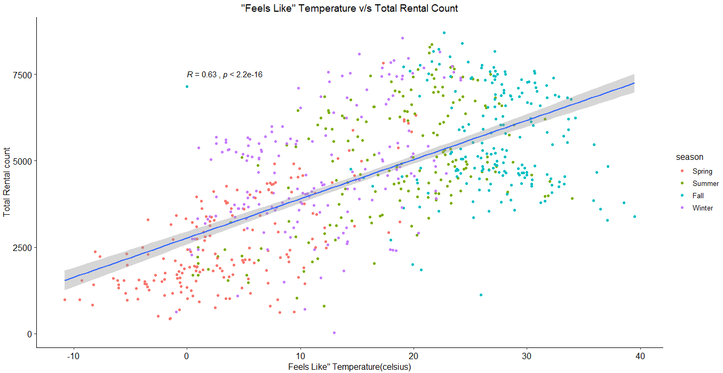
#Humidity v/s Total Rental Count
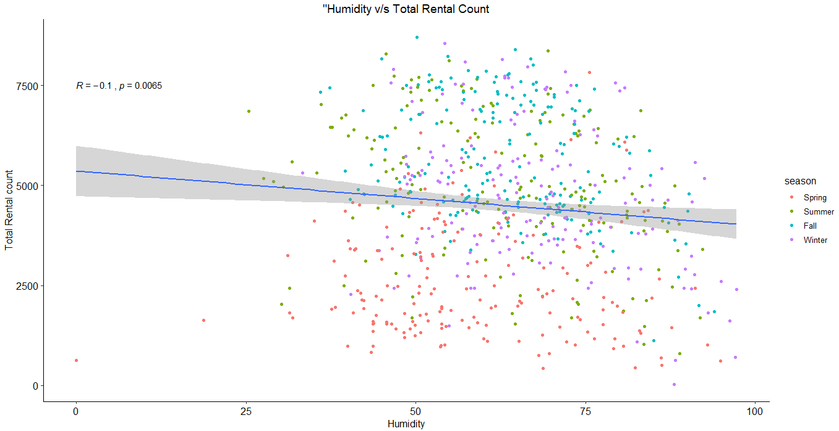
#Windspeed v/s Total Rental Count
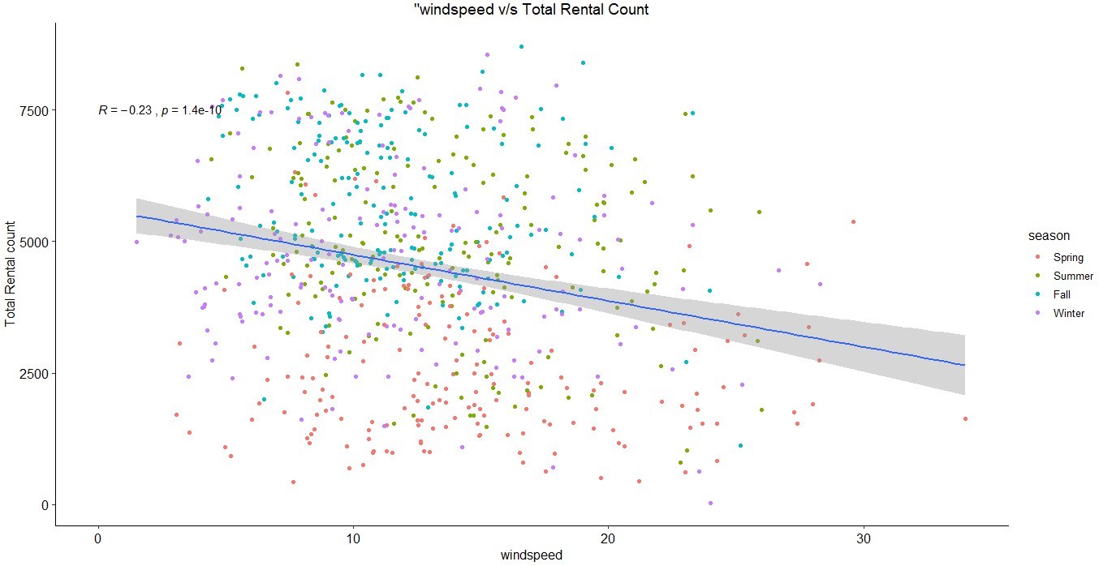

#Casual v/s Total Rental Count
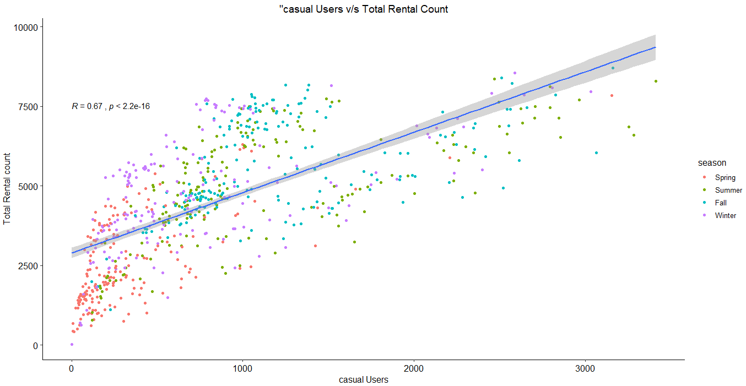
#Registered v/s Total Rental Count
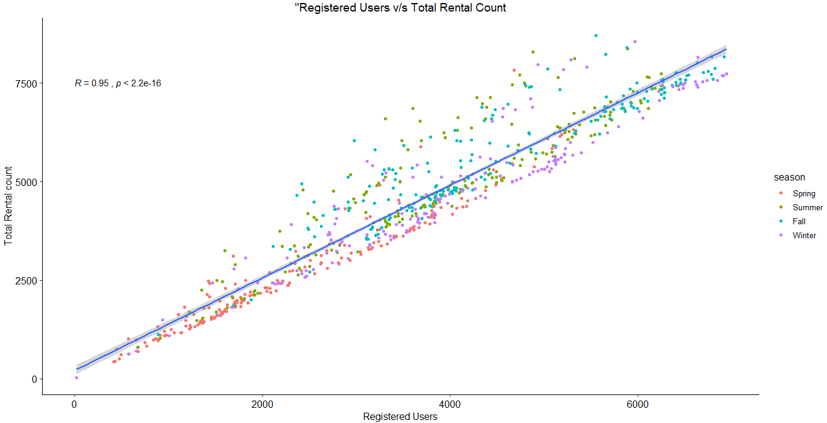

2.5 Missing Value Analysis
In statistics, missing data or missing values occur when no data value is stored for the variable in an observation. Missing values are a common occurrence in data analysis. These values can have a significant impact on the results or conclusions that would be drawn from these data. If a variable has more than 30% of its values missing, then those values can be ignored, or the column itself is ignored. In our case, none of the columns have missing values.

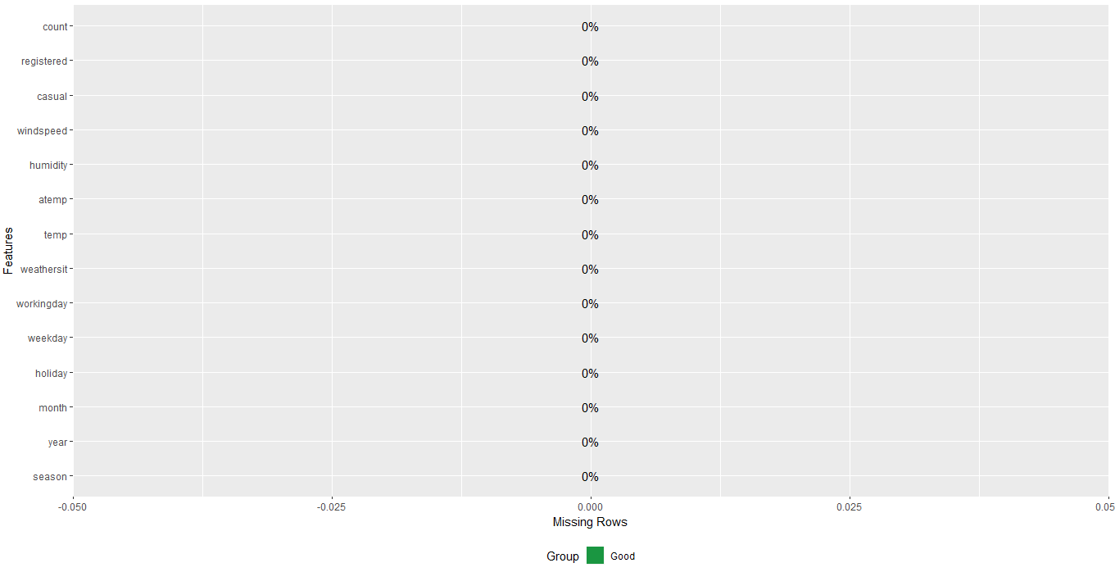

Figure: Missing Values by percentage in each column

2.6 Outlier Analysis
One of the steps in pre-processing involves the detection and removal of such outliers. In this project, we use boxplot to visualize and remove outliers. Any value lying outside of the lower and upper whisker of the boxplot are outliers. We have natural outliers in our dataset. Hence we won’t remove them
In figure we have plotted the boxplots of all continuous variables.

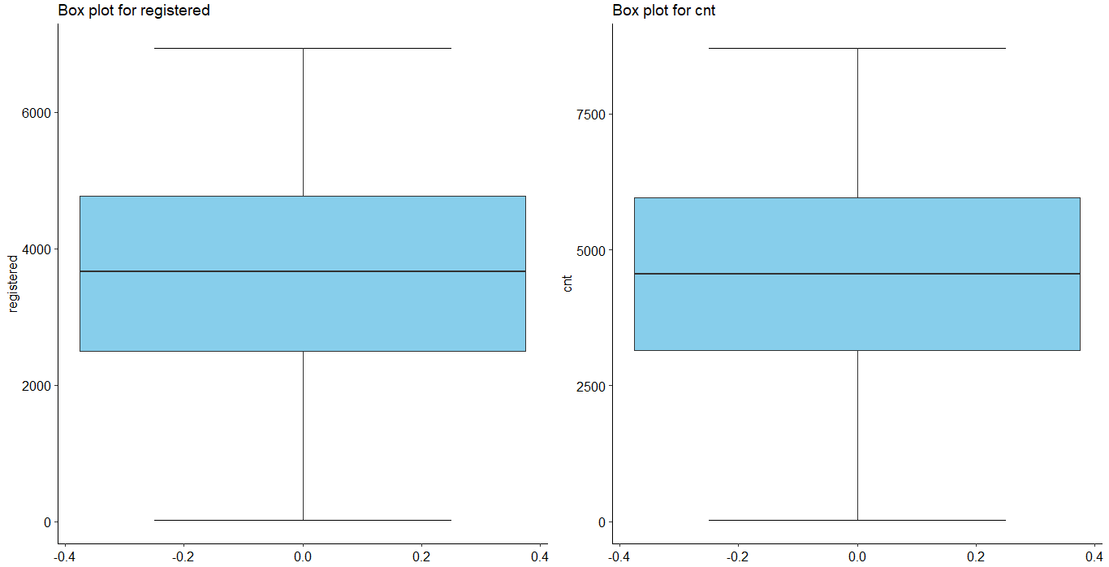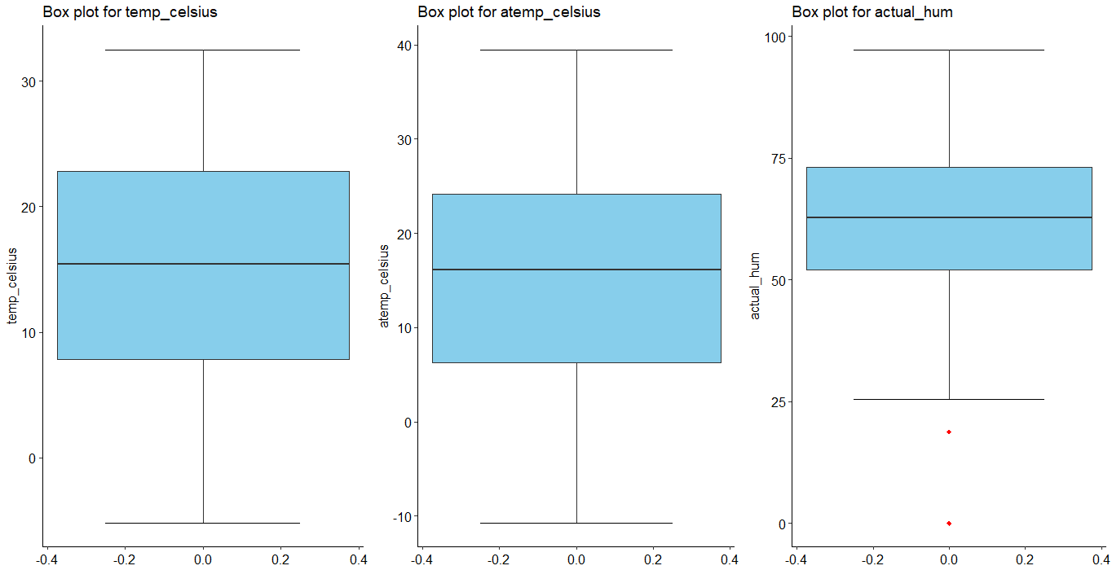

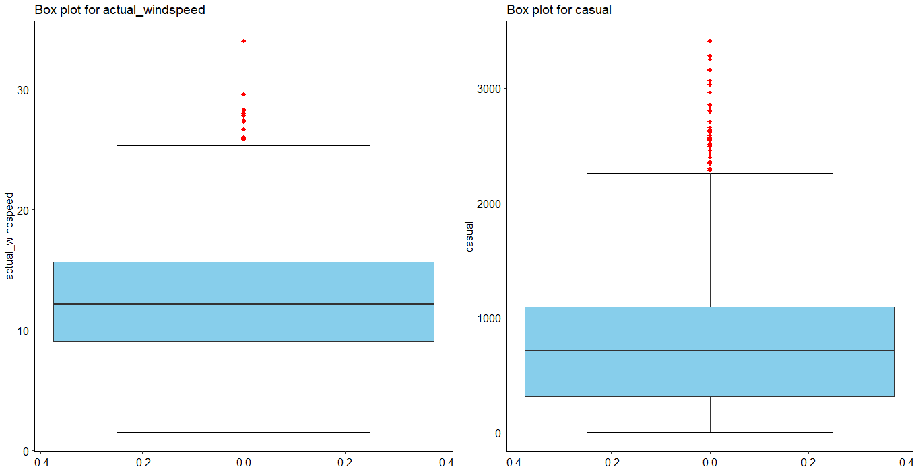

Figure – Boxplots of continuous variables with outliers

2.7 Feature Selection
Feature Selection reduces the complexity of a model and makes it easier to interpret. It also reduces overfitting. Features are selected based on their scores in various statistical tests for their correlation with the outcome variable. Correlation plot is used to find out if there is any multicollinearity between variables. The highly collinear variables are dropped and then the model is executed. Also from our business understanding we also remove those columns which might not be contributing to the dataset for example ‘instant’ and ‘dteday’.
From correlation analysis we have found that ‘temp’ and ‘atemp’ has high correlation (>0.9), so we have excluded the ‘atemp’ column from our dataset.
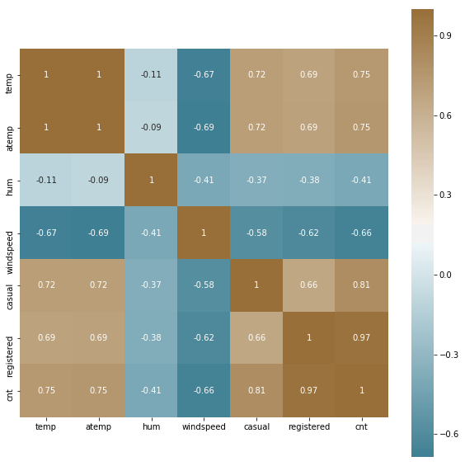

Figure – Correlation plot of Continuous variables

2.8 Feature Scaling

Feature scaling is a method used to standardize the range of independent variables or features of data. In data processing, it is also known as data normalization and is generally performed during the data pre-processing step.

Most classifiers calculate the distance between two points by the Euclidean distance. If one of the features has a broad range of values, the distance will be governed by this feature. Therefore, the range of all features should be scaled so that each feature contributes proportionately to the model and our result is not biased towards the variable greater in magnitude.
In our dataset all the predictor variables are in comparable magnitude i.e. they have range in same scale or they are already scaled.
So feature scaling is not required for this dataset.

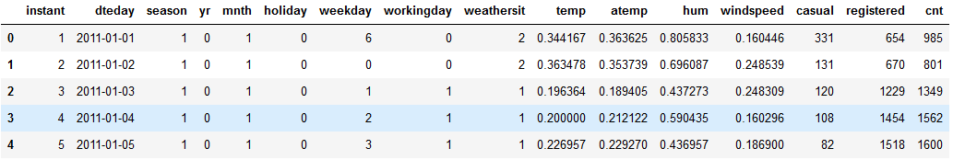

Table – Scaled Continuous variables

Chapter 3: Modelling

3.1 Model Selection

After a thorough pre-processing we will be using some regression models on our processed data to predict the target variable. The target variable in our model is a continuous variable i.e., Total Bike rental count ‘cnt’, Count of casual users ‘casual’ and Count of registered user ‘registered’. Hence the models that we choose are Linear Regression, Decision Tree, Random Forest and XG Boost. The error metric chosen for the given problem statement is Root Mean Square Error (RMSE), Mean Absolute Percentage Error (MAPE). We will select our best fit model by comparing both the statistical values.

3.2 Decision Tree

Decision Tree algorithm belongs to the family of supervised learning algorithms. Decision trees are used for both classification and regression problems.

A decision tree is a tree where each node represents a feature (attribute), each link (branch) represents a decision (rule) and each leaf represents an outcome (categorical or continues value). The general motive of using Decision Tree is to create a training model which can be used to predict class or value of target variables by learning decision rules inferred from prior data (training data).

3.2.1 Decision Tree for ‘cnt’

DECISION TREE | MAPE | RMSE | MSE | R^2
R | 7.40 | 27.05 | 10866.09 | Not Calculated
PYTHON | Not Calculated | 57.487 | 3304.795 | 0.9991

3.2.2 Decision Tree for ‘registered’

DECISION TREE | MAPE | RMSE | MSE | R^2
R | 0.583 | 48.507 | 639.601 | Not Calculated
PYTHON | Not Calculated | 78.72 | 6198.40 | 0.9975

3.2.3 Decision Tree for ‘casual’

DECISION TREE | MAPE | RMSE | MSE | R^2
R | 2.934 | 24.487 | 163.046 | Not Calculated
PYTHON | Not Calculated | 25.19 | 634.69 | 0.9984

3.3 Random Forest
Random Forest is a supervised learning algorithm. Random forest builds multiple decision trees and merges them together to get a more accurate and stable prediction. It can be used for both classification and regression problems. The method of combining trees is known as an ensemble method. Ensemble is nothing but a combination of weak learners (individual trees) to produce a strong learner.

The number of decision trees used for prediction in the forest is 100.

3.3.1 Random Forest for ‘cnt’

DECISION TREE | MAPE | RMSE | MSE | R^2
R | 8.664 | 70.95 | 1368.269 | Not Calculated
PYTHON | Not Calculated | 17.841 | 318.330 | 0.9999

3.3.2 Random Forest for ‘registered’

DECISION TREE | MAPE | RMSE | MSE | R^2
R | 0.756 | 18.113 | 328.080 | Not Calculated
PYTHON | Not Calculated | 18.351 | 336.77 | 0.9998

3.3.3 Random Forest for ‘casual’

DECISION TREE | MAPE | RMSE | MSE | R^2
R | 0.858 | 9.593 | 92.041 | Not Calculated
PYTHON | Not Calculated | 28.855 | 832.657 | 0.9979

3.4 Linear Regression

Multiple linear regression is the most common form of linear regression analysis. Multiple linear regression is used to explain the relationship between one continuous dependent variable and two or more independent variables. The independent variables can be continuous or categorical.

3.4.1 Linear Regression for ‘cnt’

DECISION TREE | MAPE | RMSE | MSE | R^2
R | 7.71 | 185.206 | 9324.123 | Not Calculated
PYTHON | Not Calculated | 1.317x10⁻⁵ | 1.736x10⁻¹⁰ | 1

3.4.2 Linear Regression for ‘registered

DECISION TREE | MAPE | RMSE | MSE | R^2
R | 5.519 | 137.364 | 5128.953 | Not Calculated
PYTHON | Not Calculated | 1.56x10⁻⁵ | 6.67x10⁻¹¹ | 1

3.4.3 Linear Regression for ‘casual’

DECISION TREE | MAPE | RMSE | MSE | R^2
R | 11.948 | 81.215 | 1792.995 | Not Calculated
PYTHON | Not Calculated | 7.132x10⁻⁶ | 5.087x10⁻¹¹ | 1

3.5 XG Boost

XG Boost (Extreme Gradient Boosting) is an advanced and more efficient implementation of Gradient Boosting Algorithm.
Advantages over Other Boosting Techniques
- It is 10 times faster than the normal Gradient Boosting as it implements parallel processing. It is highly flexible as users can define custom optimization objectives and evaluation criteria, has an inbuilt mechanism to handle missing values.
- Unlike gradient boosting which stops splitting a node as soon as it encounters a negative loss, XG Boost splits up to the maximum depth specified and prunes the tree backward and removes splits beyond which there is an only negative loss.
Extreme gradient boosting can be done using the XG Boost package in R and Python.

3.5.1 XG Boost for ‘cnt’

DECISION TREE | MAPE | RMSE | MSE | R^2
R | 5.263 | 161.427 | 7083.153 | Not Calculated
PYTHON | Not Calculated | 22.491 | 505.880 | 0.9998

3.5.2 XG Boost for ‘registered’

DECISION TREE | MAPE | RMSE | MSE | R^2
R | 0.464 | 38.859 | 410.466 | Not Calculated
PYTHON | Not Calculated | 16.695 | 278.775 | 0.9998

3.5.3 XG Boost for ‘casual’

DECISION TREE | MAPE | RMSE | MSE | R^2
R | 1.625 | 20.072 | 402.907 | Not Calculated
PYTHON | Not Calculated | 23.755 | 564.344 | 0.9986

Chapter 4: Conclusion

4.1 Model Evaluation

In the previous chapter we have seen the Mean Absolute Percentage error (MAPE), Root Mean Square Error (RMSE), Mean Squared Error (MSE) and R-Squared Value of different models.

4.1.1 Root Mean Square Error (RMSE)

It is the standard deviation of the residuals (prediction errors). Residuals are a measure of how far from the regression line data points are, RMSE is a measure of how spread out these residuals are. In other words, it tells you how concentrated the data is around the line of best fit.
1. RMSE express average model prediction error in units of the variable of interest. RMSE can range from 0 to ∞ and are indifferent to the direction of errors. They are negatively-oriented scores, which means lower values are better.
2. Taking the square root of the average squared errors has some interesting implications for RMSE. Since the errors are squared before they are averaged, the RMSE gives a relatively high weight to large errors. This means the RMSE should be more useful when large errors are particularly undesirable.

4.1.2 Mean Absolute Percentage Error (MAPE)

The mean absolute percentage error (MAPE) is a statistical measure of how accurate a forecast system is. It measures this accuracy as a percentage, and can be calculated as the average absolute percent error for each time period minus actual values divided by actual values. The mean absolute percentage error (MAPE) is the most common measure used to forecast error, and works best if there are no extremes to the data (and no zeros).

4.1.3 Mean Squared Error (MSE)

MSE basically measures average squared error of our predictions. For each point, it calculates square difference between the predictions and the target and then average those values.
The higher this value, the worse the model is. It is never negative, since we’re squaring the individual prediction-wise errors before summing them, but would be zero for a perfect model.

4.1.4 R-squared

It explains how well your selected independent variable(s) explain the variability in your dependent variable(s) R-squared gives you the percentage variation in y explained by x-variables. The range is 0 to 1 (i.e. 0% to 100% of the variation in y can be explained by the x-variables.
Variance—in terms of linear regression, variance is a measure of how far observed values differ from the average of predicted values, i.e., their difference from the predicted value mean. The goal is to have a value that is low

4.2 Model Selection

Here we will select best fit model for each of our target variables by analysing MAPE, RMSE and R² values. For this dataset each of the model is giving high accuracy hence we might face the problem of overfitting. To avoid this we will select model which is moderately fitting the dataset among all the models i.e. neither too high nor low accuracy.

4.2.1 Model selection for ‘cnt’ variable

We will select ‘Random Forest’ as our Model for ‘cnt’ variable because it has low RMSE (70.95) and MSE (1368.269) values. MAPE is 8.66% which is a good fit model.

4.2.2 Model selection for ‘registered’ variable

We will select ‘Random Forest’ as our Model for ‘registered’ variable because it has low RMSE (18.113) and MSE (328.080) values. MAPE is 0.756% which is a good fit model.

4.2.3 Model selection for ‘casual variable

We will select ‘XG Boost’ as our Model for ‘casual’ variable because it has low RMSE (20.072) and MSE (402.907) values. MAPE is 1.625% which is a good fit model.

4.3 Key Prediction

- Number of registered user count is mostly greater than casual user count throughout the year across all season.
- There is 64.87% increase in total bike rental count from year 2011 to 2012.
- Season wise Analysis of total bike rental count.

Season | 2011 | 2012 | Total Count | Percentage
1.Spring | 150,000 (12.06%) | 321,348 (15.68%) | 471,348 | 14.32
2.Summer | 347,316 (27.94%) | 571,273 (27.87%) | 918,589 | 27.89
3.Fall | 419,650 (33.75%) | 641,479 (31.30%) | 1,061,129 | 32.22
4.Winter | 326,137 (26.24%) | 515,476 (25.15%) | 841,613 | 25.56
Total | 1,243,103 | 2,049,576 | 3,292,679 | 100
About 60 % of total bikes are rented in summer and fall season together throughout the year.

- Weather situation wise analysis.

Weather Situation | Total Rental Count | Percentage Count
1. Good: Clear/Sunny | 2,257,952 | 68.58%
2. Moderate: Cloudy/Mist | 996,858 | 30.27%
3. Bad: Rain/Snow/Fog | 37,869 | 1.15%
4. Worse: Heavy Rain/Snow/Fog | NIL | NIL
As soon as weather is clear and cloudy people are renting bike more. But as rain comes in bike rental gets less and less as the condition get worse.

- Total bike rental on non-working days is about 30.38% as compared to rentals on working days which is 69.62% of total bike rentals i.e. people are renting bikes more to commute to office.
- Weekday analysis of total bike rental

Day of week | Total Rental Count
0 | 444,027
1 | 455,503
2 | 469,109
3 | 473,048
4 | 485,395
5 | 487,790
6 | 477,807

Bike rentals is almost similar through the days of week.

Chapter 5: R Code _{(Double-click to open)}
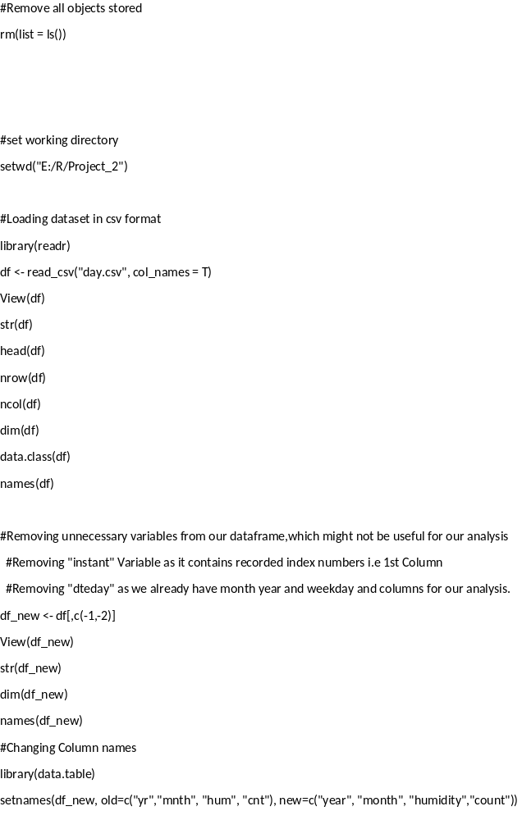

References

- For Data Cleaning and Model Development –
https://edwisor.com/career-data-scientist

- For R code
https://datacamp.com

- For Visualization and other information –
Analytics Vidya, Youtube, Udemy, Stackoveflow

